The numerical analyses of response and stability of Stone Masonary Bridges in Aizonoi Antique City in Kütahya Province of Turkey

Jun Tomiyama and Ömer Aydan
University of the Ryukyus, Dept. of Civil Eng. and Architecture, Okinawa, Japan

Halil Kumsar and Elif Özer
Pamukkale University, Denizli, Turkey

Topics: Rock mechanics and rock engineering at historical sites and monuments

Aizonoi antique city was established by Phrygians and become a part of Roman Empire and then become of a part of Seljuk, later Ottoman Empire and finally Turkey. One can find traces of various civilizations. This city was the first to introduce the fundamentals of the modern stock exchange. This city was also the first city in the world to introduce the flood protection measures by constructing dams and embankment walls. In other words, it is the city of the birth of the hydraulic engineering of modern civil engineering. The city had three stone masonry bridges made of marble. Two of these three bridges are remaining and it is still used today. The bridges have been performed very well even under very heavy trucks of modern times. However, the traffic has been restricted to light vehicles such as cars and they are still in use.
The authors have performed some site investigations and surveying of two remaining stone bridges. In this study, the response and stability of stone bridges are investigated using finite element method under various loading conditions. The authors describe the results of the investigations and analyses. This study also confirm why these stone bridges performed very well so far since their construction about 2000 years ago.
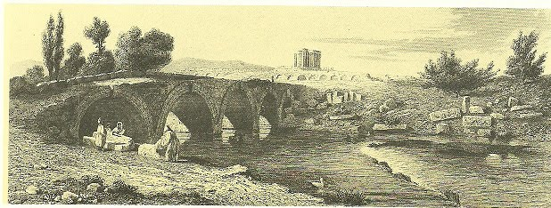
Figure 1. An 19th century engravure of the stone masonry bridge in Aizonoi

Keywords: Phrygian, Roman, Stone Masonry Bridge, Numerical Analysis, stability

