Comparison of Ground Motion Prediction Equations with Ground Motion Data from Earthquakes in Southern Aegean Area

Aykut Semerci¹, Ebru Harmandar²*

¹Department of Architecture and City Planning Department, Pamukkale University
²Department of Civil Engineering, Muğla Sıtkı Koçman University
*Corresponding author:ebruharmandar@mu.edu.tr

Abstract

Ground motion prediction equations are used to estimate ground motion parameters in seismic hazard analyses. The validity of these equations has been probed for local regions. The aim of this study is investigating the compatibility of ground motion prediction equations selected in international and national projects with respect to magnitude, distance, and site scaling implied by ground motion data from Southern Aegean Area. This province is one of the most seismically active areas of the Eastern Mediterranean region. Comparisons are done for estimations from the ground motion prediction equations developed in the Next Generation Attenuation (NGA) project for application to shallow crustal zones and subduction zones. The observed data recorded by 160 strong motion stations in the National Strong Ground Motion Network (operated by the Earthquake Department of the Disaster and Emergency Management Presidency, AFAD) (Mercuri et al. 2013) triggered by earthquakes with magnitude greater than 5 are used in terms of peak ground acceleration and spectral acceleration.

Keywords: Strong ground motion data, ground motion prediction equations, Southern Aegean Area

Introduction

Ground motion prediction equations (GMPEs) involve the characterization of earthquake ground motion for engineering applications. Characterization of earthquake ground motion is defined in terms of peak acceleration, spectral acceleration or duration, magnitude, site-source distance, site condition and other parameters (Scassera et al., 2008). Next Generation Attenuation (NGA) project advanced a series of GMPE’s applications to shallow crustal zones and subduction zones. Some of the Akkar et al. (2014), Zhao et al. (2006), Lin and Lee (2008), Garcia et al. (2005) and Megawati and Pan (2010).

This study aims to investigate the compatibility of ground prediction equations selected in international and national projects concerning magnitude, distance, and site scaling implied by ground motion data from the Southern Aegean area.

Active Fault System in Southern Aegean and Seismicity

The Southern Aegean area is located at Bornova Flysch Zone, Menderes Massif. Figure 1 represents the seismo-tectonic and geological setting.

Aegean Depression System

The Aegean Area consists of many blocks and has an activity of normal fault mechanism in E-W direction. The region is generally under the influence of a PPE-SSW-pulling regime. The main NNE-SSW expansion direction dominating the area is the focal mechanism of these earthquakes. It has been obtained as a result of solutions and shows compatibility with T axis directions. These areas are Bakırçay-Simav depression (Edremit Bay), Gediz-Küçük, Menderes depression, Büyük Menderes and Gökova Bay depressions (Figure 2).
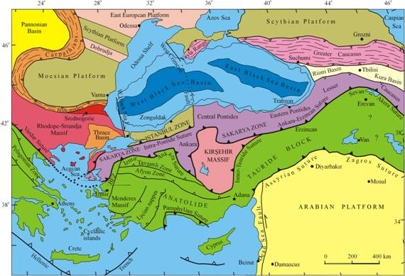
Figure 1. Seismo-tectonic and Geology Map of Turkey (Aral Okay, 2005)

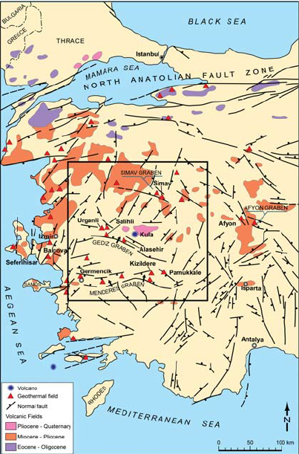

Figure 2. Geologic Map of Western Turkey with Major Fault Zones
(Faulds et al., 2010)

a.) Active Faults in Muğla Region

Muğla - Yatağan Fault Zone: This fault zone consists of approximately 40 km long parallel NW-SE trending faults extending between 15 km SE of Muğla and Yatağan. The faulting mechanism of this section between Ortayaraş-Gökpınar is a normal fault with a left-lateral strike-slip component.

Ula (Muğla) – Ören (Muğla) Fault Zone: This fault zone extends in the direction of WSW by separating the Muğla-Yatağan fault zone to a narrow-angle in the east of Muğla. The total length of the fault zone on land is around 60 km.

Karaova (Muğla) – Milas (Muğla) Fault Zone: This fault zone consists of NW-SE trending parallel fault sets that can be traced in metamorphic rocks surfacing between Karaova and Milas. The 20km section of this fault zone accepts as a possible alive fault due to morphology. (Şaroğlu et al. 1987).

b.) Between Kemalpaşa - Torbalı - Seferihisar - Kuşadası (İzmir) Active Faults: Some faults in the NE-SW general direction, which trace in upper Miocene and older rocks in the west of Menderes massif, are collected under this class. In the east of Kuşadası, there are sliding scratches on the fault plane that cuts the limestones before Miocene, giving the normal fault character with a left-sided strike-slip component. In the south of Kemalpaşa, sliding scratches on the fault planes cutting the upper Miocene aged limestone and sandstones indicate the directional strike. Dumont et al. (1979) stated that the fault Efes near Söke was a normal fault that initially operated with a left-sided strike-slip component.

c.) Active Faults of Büyük Menderes Graben: Büyük Menderes graben within the Büyük Menderes river in Western Anatolia is located between Denizli in the east and Ortaklar in the west (Şaroğlu et al. 1998). This depression area, which is approximately 140 km long, changes direction towards Söke the west towards NW, and the east, towards NW-SE towards Honaz.

The faults in this area are normal faults with dip-slip and have strike-slip components at the east and west ends. The faults that present the graben from the north and extend between Ortaklar and Sarayköy are generally in E-W course and form a 10 km wide zone that runs parallel to each other.

d.) Gölhisar-Çameli (Denizli) Fault: Three fault zones extending between Kelekçi-Altınyayla, south of Gölhisar, 40 km long and 30 km wide parallel to each other, have been named as Gölhisar-Çameli fault (Şaroğlu et al. 1987). Based on typical fault valleys specific to the strike-slip faults, fault-controlled drains, and left laterally shifted streams. It is argued that the fault is a left-sided strike-slip fault and alive due to the impact of Quaternary sediments.

e.) Fethiye-Köyceğiz Active Faults: Destructive earthquakes frequently occur in the region due to the small-scale faults between Fethiye and Köyceğiz.

Analysis of Recorded Ground Motion

In the present study, M >5.0 investigated events occurred in the Southern Aegean Area. These ground motion data were recorded by the AFAD between 2000 and 2017 years. The observed data recorded by 100 strong motion stations and 35 earthquakes recording in the National Strong Ground Motion Network (operated by the Earthquake Department of the Disaster and Emergency Management Presidency). These acceleration data were processed. Frequency range of Butterworth filter was detected for each earthquake ground motion data. The ranges differ between 0.1-25 Hz, 0.1- 35 Hz, 0.2-35 Hz, 0.3-25 Hz. The stations located within the 100 km epicentral area for each event are considered. Table 1 lists the general properties of earthquakes used in this study.

For the evaluation of earthquake ground motion data in the Southern Aegean Area, ground motion prediction equations defined in SHARE (Seismic Hazard Harmonization in Europe) project are used. GMPEs for both shallow crustal zones and subduction zones including Next Generation Attenuation (NGA) relations are considered. The properties of selected GMPEs are listed in following section.

Ground Motion Prediction Equations (GMPEs)

a.) Lin and Lee (2008)
Based on the subduction zone earthquake ground-motion attenuation models (Crouse, 1991; Youngs et al., 1997), the PGA attenuation model of this relation is;

$In\left(PGA\right)=c_{1}+{Mc}_{2}+c_{3}In\left(R+c_{4}e^{c_{5}M}\right)+c_{6}H+c_{7}Z_{t}$ (1)

where PGA(g) is the geometric mean of the two horizontal PGA values, M is the moment magnitude M_{w} in this equation, R is the hypocentral distance (km), H is the focal depth (km), Z_{t} represents the earthquake type (Zt =0, interface; Zt =1, intraslab) (Lee et al., 2008).

Table 1. Earthquakes Used in This Study

Event | Town/City | Date | Latitude °N | Longitude °W | M_{w} | Depth (km) | Records
1 | Honaz-Denizli | 21.04.2000 | 37,88 | 29,36 | 5,4 | 19,90 | 3
2 | Merkez-Denizli | 04.10.2000 | 37,90 | 29,03 | 5,0 | 2,80 | 2
3 | Soma-Manisa | 22.06.2001 | 39,34 | 27,91 | 5,2 | 7,00 | 1
4 | Sultandağı-Afyon | 03.02.2002 | 38,52 | 31,20 | 6,5 | 22,10 | 1
5 | No-Name | 03.02.2002 | 38,72 | 30,89 | 5,4 | 35,40 | 1
6 | Merkez-Afyon | 03.02.2002 | 38,63 | 30,88 | 5,8 | 24,90 | 1
7 | Seferihisar-İzmir | 10.04.2003 | 38,25 | 26,89 | 5,7 | 11,30 | 1
8 | Seferihisar-İzmir | 17.04.2003 | 38,16 | 26,63 | 5,2 | 11,50 | 1
9 | Buldan-Denizli | 23.07.2003 | 38,05 | 28,89 | 5,3 | 28,30 | 6
10 | Buldan-Denizli | 26.07.2003 | 38,06 | 28,91 | 5,4 | 21,30 | 6
11 | Gokova-Gulf | 03.08.2004 | 36,86 | 27,78 | 5,2 | 10,00 | 1
12 | Bodrum-Muğla | 04.08.2004 | 36,84 | 27,77 | 5,5 | 10,00 | 1
13 | Gokova-Gulf | 04.08.2004 | 36,83 | 27,82 | 5,2 | 10,00 | 1
14 | Bodrum-Muğla | 04.08.2004 | 36,86 | 27,81 | 5,2 | 12,90 | 1
15 | Bodrum-Muğla | 04.08.2004 | 36,84 | 27,78 | 5,3 | 10,00 | 1
16 | Ula-Muğla | 20.12.2004 | 37,01 | 28,28 | 5,3 | 12,50 | 6
17 | Gokova-Gulf | 10.01.2005 | 37,01 | 27,81 | 5,4 | 15,80 | 2
18 | Gokova-Gulf | 10.01.2005 | 36,91 | 27,83 | 5,3 | 12,20 | 2
19 | Gokova-Gulf | 11.01.2005 | 36,98 | 27,74 | 5,0 | 14,90 | 2
20 | Aegean Sea | 17.10.2005 | 38,19 | 26,68 | 5,5 | 20,50 | 2
21 | Aegean Sea | 17.10.2005 | 38,16 | 26,69 | 5,1 | 2,20 | 1
22 | Aegean Sea | 17.10.2005 | 38,14 | 26,66 | 5,2 | 4,00 | 1
23 | Urla-İzmir | 17.10.2005 | 38,22 | 26,66 | 5,8 | 18,60 | 2
24 | Aegean Sea | 17.10.2005 | 38,20 | 26,64 | 5,2 | 11,00 | 2
25 | Urla-İzmir | 17.10.2005 | 38,15 | 26,66 | 5,1 | 2,00 | 2
26 | Urla-İzmir | 17.10.2005 | 38,18 | 26,56 | 5,0 | 21,40 | 1
27 | Urla-İzmir | 18.10.2005 | 38,21 | 26,51 | 5,0 | 25,50 | 1
28 | Aegean Sea | 19.10.2005 | 38,17 | 26,70 | 5,1 | 2,50 | 1
29 | Aegean Sea | 20.10.2005 | 38,15 | 26,67 | 5,8 | 15,40 | 1
30 | Urla-İzmir | 21.10.2005 | 38,20 | 26,57 | 5,0 | 19,20 | 1
31 | Aegean Sea | 29.10.2005 | 38,19 | 26,64 | 5,1 | 2,20 | 1
32 | Denizli-Çameli | 29.10.2007 | 37,07 | 29,32 | 5,3 | 28,90 | 4
33 | Denizli-Çameli | 16.11.2007 | 36,94 | 29,30 | 5,1 | 22,00 | 3
34 | Ege Denizi | 12.06.2014 | 38,90 | 26,27 | 5,1 | 22,48 | 25
35 | Muğla-Ula | 13.04.2017 | 37,15 | 28,65 | 5,0 | 11,33 | 12

b.) Garcia et al. (2005)
The adopted functional form for inslab area is;

$\log{Y}=c_{1}+{M_{w}c}_{2}+c_{3}R-c_{4}logR+c_{5}H$ (2)

where Y is the horizontal PGA values, M_{W} is the moment magnitude, R is the hypocentral distance (km), H is the focal depth (km).

c.) Zhao et al. (2006)
This relation used to estimate ground motions for intraslab events and the active shallow crust has a form of

$In\left(Y\right)=aM_{w}+bx-In\left(r\right)+e\left(h-h_{c}\right){}_{h}+F_{R}+S_{I}+S_{s}+S_{SL}\log\left(x\right)+c_{k}$ (3)

$r=x+c exp⁡(dM_{w})$ (4)
where Y is PGA (cm/sec²), M_{W} is the moment magnitude, x is the source distance in km, h is the focal depth (km) (Md. Zillur, 2019). F_{R} is zero for crustal events with a reverse faulting mechanism. S_{I} is zero for interface events. S_{S} is zero for subduction slab events. S_{L} is a magnitude-independent path. C_{k} is the site-class term. h_{c} is a depth constant.

d.) Akkar and Cagnan (2010)
This equation accounts for saturation and magnitude-dependent decay effects are;

For M ≤ c1:

$In\left(Y\right)=a_{1}+a_{2}\left(M-c_{1}\right)+a_{4}{\left(8.5-M\right)}^{2}+\left[a_{5}+a_{6}\left(M-c_{1}\right)\right]In\sqrt{R^{2}+a_{7}^{2}}+a_{8}F_{N}+a_{9}F_{R}$ (5)

For M > c1:
$$In\left(Y\right)=a_{1}+a_{3}\left(M-c_{1}\right)+a_{4}{\left(8.5-M\right)}^{2}+\left[a_{5}+a_{6}\left(M-c_{1}\right)\right]In\sqrt{R^{2}+a_{7}^{2}}+a_{8}F_{N}+a_{9}F_{R}$$ (6)

where Y is PGA (cm/sec²), the reference magnitude is c₁, and it is 6.5 in this study. The parameters F_{N} and F_{R} are dummy variables for the influence of faulting and are taken values of 1 for normal and reverse faults and zero otherwise (Kartal et al, 2014).

e.) Megawati and Pan (2009)
This relation developed using the earthquake magnitude and source-station distance represent the complicated and time-consuming ground-motion simulations (Sengupta P, 2014). The functional form is;

$In\left(Y\right)=a_{0}+a_{1}\left(M-6\right)+a_{2}{\left(M-6\right)}^{2}+a_{3}InR+{(a}_{4}+a_{5}M)R$ (7)

where Y is PGA, PGV or RSA values at various natural periods. The unit for the acceleration values is cm/s² and that for velocity is cm/s. M is the moment magnitude and R is the distance, in km.

Comparison of observed data with GMPEs

Observed earthquake ground motion data from the selected active shallow and subduction earthquakes (see Table 1) has been compared with ground motions estimated by the aforementioned equations. For the comparison of PGA data, the equations from Garcia et al. (2005), Lee and Lin (2008), Akkar and Cagnan (2010), Zhao et al. (2006), Megawati and Pan (2009) has been used. GMPEs and observed data for both active shallow and subduction zones are considered together due to the difficulty of separation of earthquakes.

Figure 3 represents the comparison of observed PGA data with selected aforementioned GMPEs. The values obtained from Lee and Lin (2008) and Zhao et al. (2006) equations are higher than the observed data. These relations are valid for the data recorded during subduction zone earthquakes. In this study, earthquake data from this zone is rare. These may affect the results. The estimated data obtained by Akkar and Cagnan (2010) correlates well with observed data. Considering all schemes, ground motion prediction equations fulfill the upper and lower band of observed data.

In Figure 4, observed PGV data is compared with GMPEs proposed by Garcia et al. (2005), Akkar and Cagnan (2010), and Megawati and Pan (2009). Megawati and Pan (2009) correlate with a lower band of the observed data at a distance of higher than 20 km. The reason may be because of the scarce recorded data at the shorter distance. Akkar and Cagnan (2010) and Garcia et al. (2005) have compatibility with the observed data. However, these equations were revised concerning region-specific data.
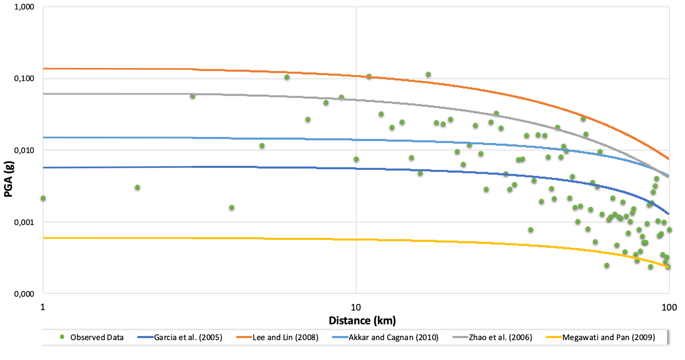
Figure 3. Comparison of observed PGA data with related GMPEs
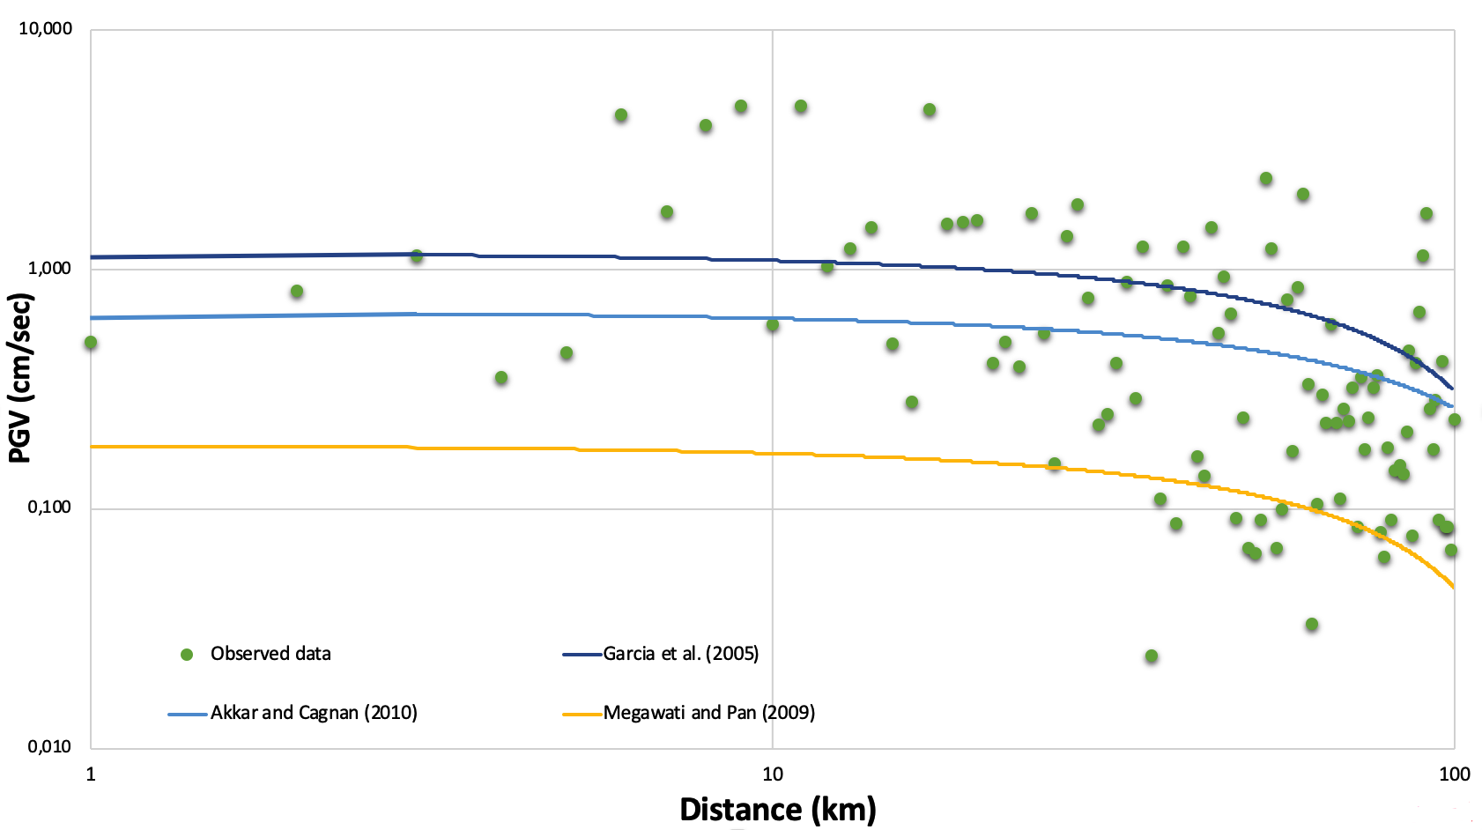
Figure 4. Comparison of observed PGV data with related GMPEs
Observed spectral acceleration data are represented in Figure 5 and Figure 6 with GMPEs by Lee and Lin (2008), Akkar, and Cagnan (2010), Zhao et al. (2006). Spectral acceleration at T=0.2 sec and T=1.0 sec compared with the related ground motion predictions. Both observed data from the active shallow zone and subduction zone are considered together because of the scarcity of data. For further study, it is planned to separate and inspect the relation between observed data and ground motion prediction equations in detail.

Figure 5 represents the compatibility of Sa (T=0.2 sec) with related GMPEs. Akkar and Cagnan (2010) correlate well in the distance band from 20 km to 100 km. Lin and Lee (2008) seem to is higher than the observed data. However, it covers the upper band of observed data. It is related to the observing data from the subduction zone. Likewise, as expected, the correlations in Figure 6 are compatible with Figure 5.
Figure 5. Comparison of Sa (T=0.2 sec) data with related GMPEs
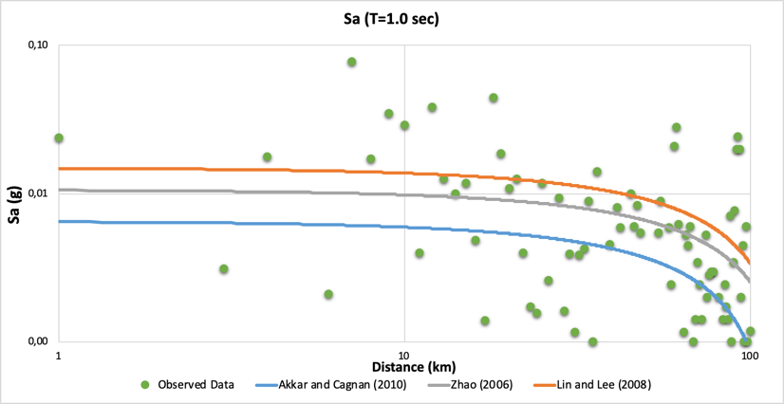
Figure 6. Comparison of Sa (T=1 sec) data with related GMPE

Conclusions

In this study, ground motion prediction equations mentioned and analyzed in SHARE project for active shallow and subduction zones are used: Garcia et al. (2005), Lee and Lin (2008), Akkar, and Cagnan (2010), Zhao et al. (2006), Megawati and Pan (2009). Observed earthquake ground motion data from the selected active shallow and subduction earthquakes recorded by Turkish Strong Motion Station Network of AFAD are compared with these GMPEs. The compatibility is investigated in terms of peak ground acceleration (PGA), peak ground velocity (PGV) and spectral acceleration at T=0.2 and T=1 sec.

Even though good correlation with observed data and related ground motion prediction equations has been observed in a wide range, it could be important that since the development of computer technology, ground motion prediction equations may be improved.

This preliminary study for the evaluation of recorded data using ground motion prediction equations in Southern Aegean Region is important to understand the general characteristics of earthquake data and compliance of GMPEs. When evaluated, more earthquake data are considered to analyze the compatibility of observed and estimated data by GMPEs in a statistical procedure for the further study.

References

Abrahamson N., Silva WJ (2008) Summary of the Abrahamson and Silva NGA ground-motion relations, Earthquake Spectra 24:67–97.
Abrahamson N., Silva WJ, Kamai R (2014) Summary of the ASK14 ground motion relation for active crustal regions, Earthquake Spectra 30(3):1025–1055.
Akkar S, Cagnan Z., (2010) A Local Ground-Motion Predictive Model for Turkey, and Its Comparison with Other Regional and Global Ground-Motion Models, Bulletin of the Seismological Society of America, Vol. 100, No. 6, pp. 2978–2995
Crouse, C. B. (1991). Ground-motion attenuation equation for earthquake on Cascadia subduction-zone earthquake, Earthq. Spectra 7, 210–236.
Dumont J.F et al., (1979) Güneybatı Anadolu’daki grabenlerin oluflumu [Formation of West Anatolian grabens]. Mineral Research and Exploration Institute (MTA) of Turkey Bulletin 92, 7–7.
Faulds J., (2010) Characterizing Structural Controls of Geothermal Reservoirs in the Great Basin, USA, and Western Turkey: Developing Successful Exploration Strategies in Extended Terranes.
Garcia et al., (2005) Inslab Earthquakes of Central Mexico: Peak Ground-Motion Parameters and Response Spectra, Bulletin of the Seismological Society of America, Vol. 95, No. 6, pp. 2272–2282.
Kartal, R.F., Beyhan, G., Keskinsezer, A. et al. (2014) Seismic hazard analysis of Mersin Province, Turkey using probabilistic and statistical methods. Arab J. Geosci. 7, 4443–4459.
Lee et al., (2008) Ground-Motion Attenuation Relationships for Subduction-Zone Earthquakes in Northeastern Taiwan, Bulletin of the Seismological Society of America, Vol. 98, No. 1, pp. 220–240.
Md. Zillur Rahman, (2019) Probabilistic Seismic Hazard Analysis With Nonlinear Site Response And Liquefaction Potential Evaluation For Deep Sedimentary Deposits.
Megawati K. and Pan C., (2009) Ground-motion attenuation relationship for the Sumatran megathrust earthquakes, Earthquake Engng Struct. Dyn. 2010; 39:827–845.
Mercuri et al. (2013) Scaling earthquake ground motions in western Anatolia, Turkey. J. Phys. Chem. Earth.
Saroglu F., Emre Ö, Boray A., (1987) Türkiye’nin diri fayları ve depremsellikleri. MTA Rapor No394.
Sengupta P, (2014) Hysteresis Models and Fragility Assessments of Reinforced Concrete Structural Components, Doctor of Philosophy/ Nanyang Technological University Singapore
Scassera et al., (2008) Site characterization of Italian recording stations for new ground motion predictions, Roma
Youngs, R. R., S. J. Chiou, W. J. Silva, and J. R. Humphrey (1997). Strong ground motion attenuation relationships for subduction zone earthquakes, Seism. Res. Lett. 68, 58–73.
Zhao et al., (2006) Attenuation relations of strong ground motion in Japan using site classification based on predominant period, Bulletin of the Seismological Society of America, Vol. 99, No. 3, pp. 898–913.

