Comparison of sound absorption properties of some commercial fibrous materials and nanofibers

C Akduman¹
¹ Pamukkale University, Denizli Vocational School of Technical Sciences, Department of Textile Technology, 20100, Denizli, Turkey
cakduman@pau.edu.tr

ABSTRACT

This study summarizes the general information about sound, sound absorption and acoustic properties of some commercial acoustic materials with novel nanofibers. It was seen that; acoustic materials should have some thickness and show some sound permeability. On the other hand, nanofibers with a supporting layer could be promising material for this purpose.

Key Words: Acoustic, Sound Absorption, Nanofibers, Pore Size, Air Permeability

1. INTRODUCTION

Sound is an inherent constituent of environment, from which we cannot get away. It is created when a material or a thing vibrates. These vibrations move through a medium (solid, liquid or gas) in a wave form from the emitter to the receiver [1]. Sound is typically described in terms of the loudness (amplitude) and the pitch (frequency) of the wave. Loudness (also called sound pressure level) is measured in logarithmic units called decibels (dB). On the other hand, noise is the unwanted loud sound that dominates the wanted sound and disturbs people and animals in many ways. Noise pollution can also be defined as the excessive sound that can negatively affect the quality of human life [2]. The ever-increasing number of vehicles, construction work, large buildings, household appliances, railway transport, aircraft and industrial machinery cause noise pollution to increase. Either by preventing or suppressing the noise creation, or using sound absorbing materials noise can be controlled. Today, sound absorbing materials or acoustic materials that can reduce the sound energy, are used to control the noise pollution and reduce the noise levels from various sources.

Noise reduction coefficient (NRC) and noise attenuation are the parameters that describe the ability of these materials to reduce the noise. NRC represents the amount of sound energy absorbed by a material when sound wave strikes a particular surface, which ranges from 0 to 1. NRC value of 0 indicates perfect reflection; whereas NRC of 1 indicates perfect absorption. NRC is calculated by acoustic instruments using frequencies of 250, 500, 1000 and 2000 Hz [3,4].

Acoustic materials absorb and dissipate the energy converting some into heat when sound travels through them. Materials such as porous textile structures, stone wool, glass wool and foamed plastic are generally used for various acoustic insulation applications. The porous materials with porosity of >90 % allow sound to enter into the structure. A series of interlocking pores in the porous material help in converting the sound energy into heat. The porous materials used for acoustic purposes can be classified as porous foam or fibrous structure [5,6]. The nature of the pores in the structure and the fiber configuration affects the acoustic properties. Among the textile structures, nonwovens are preferred for acoustic application [7]. The sound absorption characteristics of an acoustic material depend on its thickness, elastic modulus, flow resistance and porosity [5]. By altering the structure, it is possible to achieve similar sound absorption using a lighter textile structure instead of a bulkier material.

Due to the increasing environmental concerns and demands of legislative authorities, the use of traditional composites such as glass, carbon, or aramid is decreasing. Instead of these composites, light weight sound absorbing papers and fibrilled fibers supported felts are preferred.

In this study acoustic properties of some commercial acoustic materials with nanofiber supported felt structures were compared and possibility of using nanofibers for acoustic materials was investigated. Six different thickness of Polyvinylidene fluoride (PVDF) nanofiber with and without felt were produced for this purpose.

2. EXPERIMENTAL

PVDF (Kynar 761A) was provided from Abalıoglu Açık Kart Bilgi Teknolojileri as a gift. Acetone, dimethylacetamide (DMAc) and tetraethylammonium bromide (TEAB) were purchased from Sigma Aldrich Company. Homogeneous PVDF solutions were prepared by dissolving 16% (w/v) of PVDF powder in acetone/ Dimethylacetamide (DMAc) (1:4 v/v) and 0,015 g TEAB was added to each 30 ml PVDF solution and stirred for 3h.

Electrospun PVDF solutions were coded with their collection periods in minutes and coded as16PVDF15, 16PVDF30, 16PVDF60, 16PVDF180, 16PVDF300 and 16PVDF600. Electrospinning method was used for nanofiber production. A polyester felt (120 g/m²) is also commercially supplied as a supporting layer. Two nonwoven glass fiber coded with JM7 and JM9, two well-known commercial cellulosic paper coded with ACLC and SND-Tex a commercial fibrilled bulky felt acoustic products coded with TRY-Felt were selected for comparison and commercially supplied.

The fiber morphology of the PVDF nanofibers and all commercial acoustic products were characterized by a scanning electron microscope (SEM: Zeiss SUPRA 40VP). SEM images help to understand more about the shape and size of the investigated fibers and porosity of the material. But precise pore size measurement and pore size distribution of the samples were measured by capillary flow porometry. The mean flow pore size (MFP) of the filters was calculated from wet, dry and half dry conditions.

Another important property of the sound absorbing material is air permeability. It determines the ability of air flow through the fabric and is commonly affected by the porosity of the structure; pore characteristics and fabric thickness. In this study air permeability was determined through 5 cm² area at 200 Pa pressure drop according to EN ISO 9237.

The SACs of the nanofibers produced were measured using a two-microphone impedance tube (TestSens Soundtube) in accordance with TS EN ISO 10534-2. A 5 cm gap between the sample and the rigid wall of the tube were left during the measurement. The sound absorption coefficient (SAC) for 1/3 octave band frequencies (250, 315, 400, 500, 630, 800, 1000, 1250, 1600, 2000, 2500, 3150, 4000, 5000 Hz) were recorded and NRC is a single number rating calculated by determining the arithmetic mean of the SACs in the 250, 500, 1000 and 2000 Hz 1/3-octave frequency bands.

3. RESULTS AND DISCUSSION

Images of TRY-Felt, JM9, JM7, SND-Tex and ACLC were given in Fig.1 and SEM images of these commercial acoustic products were given in Fig. 2. Since ACLC and SND-Tex were thin paper product, single image was given for each of them. Cellulosic fibers, intense binder existence and supporting synthetic fibers could be seen from the images. JM7 and JM9 were glass fiber products and in order to better handle these products a polyester or a polypropylene layer is existed on the upper surface. Relatively thick fibers and jointed parts could be seen from Fig. 2c and e. Intense thin glass fibers could be seen from Fig. 2d and f. TRY-Felt is a laminated product and fibrillated white surface fibers could be seen from Fig. 2g. This product was delaminated and SEM images of black parts were also given in Fig. 2h. Thick fibers and binder application could be seen.
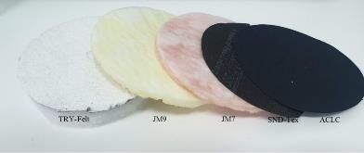
Figure 1. Images of TRY-Felt, JM9, JM7, SND-Tex and ACLC

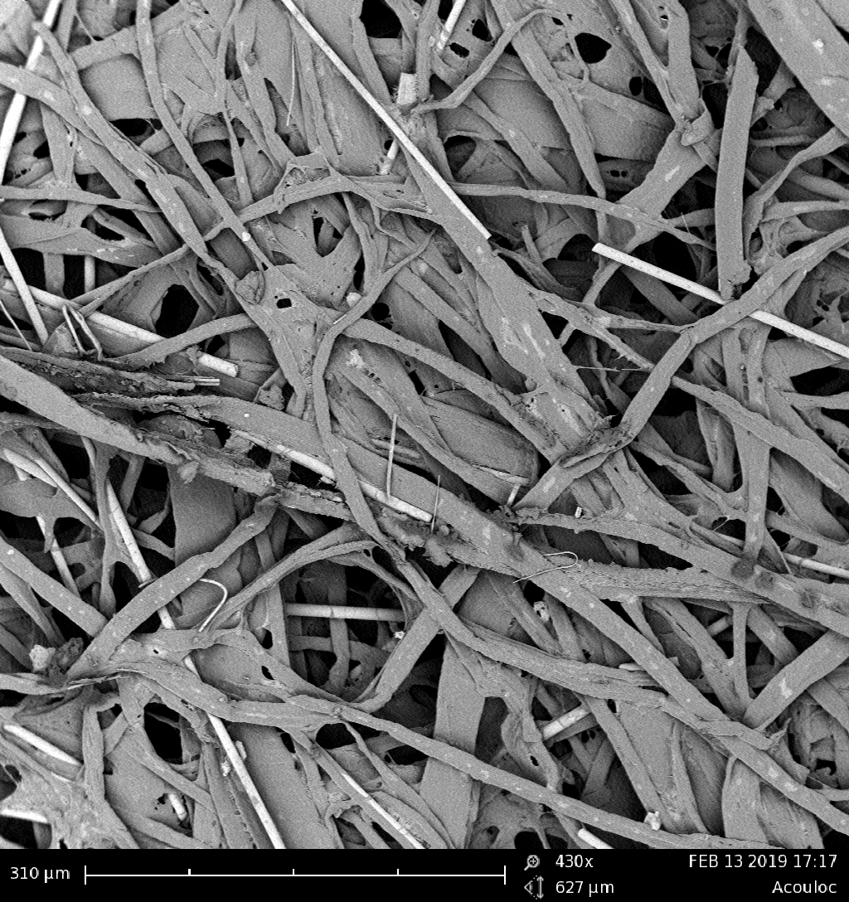 | 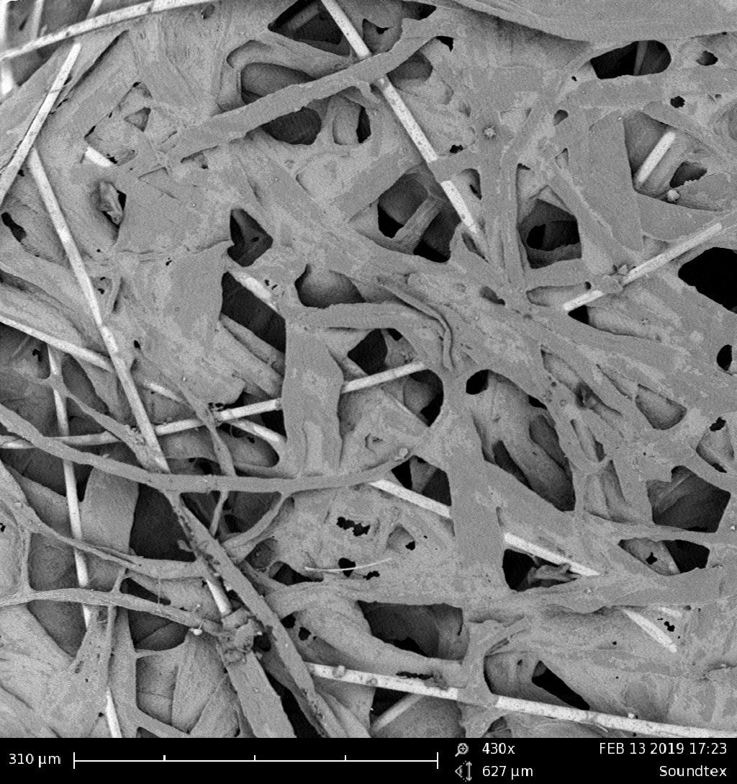
a)ACLC | b)SND-Tex
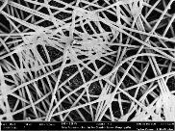 | 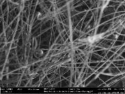
c)JM7-Surface | d)JM7-Inside
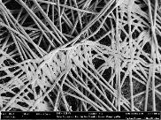 | 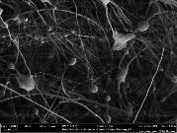
e)JM9 | f)JM9-Inside
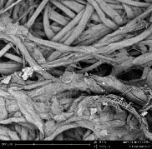 | 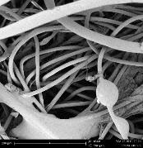
g)TRY-Felt /Fibrilled white surface | h)TRY-Felt/Black delaminated part
Figure 2. SEM images of a)ACLC, b)SND-Tex, c)JM7-Surface, d)JM7-Inside, e) JM9-Surface, f) JM9-Inside, g) TRY-Felt /Fibrilled white surface and TRY-Felt/Black delaminated part
Although cellulosic paper materials, ACLC and SND-Tex were very thin materials, they have high mean flow pore sizes (MFP) of 25,7 and 48.9 µm, and their air permeability values were 403 and 173 L/m²/s respectively. NRC values of these products were measured 0.52 and 0.45, respectively. Glass fiber products had also high air permeabilities such as 424 and 307 L/m²/s, with relatively lower pore sizes of 18.4 and 12.5 µm, their NRC values were 0.53 and 0.56. Surface fibrillated laminated commercial felt product showed the highest NRC of 0.62 with 14.6 µm pore size and 168 L/m²/s air permeability. In case of commercial products, better NRC values belong to acoustic products which have relatively small pore size with sufficient air permeability. Acoustic materials transform the energy of sound wave to heat when the sound wave is passed through these materials by their series of interlocking pores. If air permeability is too low, sound would not enter into the acoustic material and would be reflected.
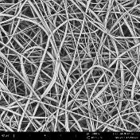
a)PVDF nanofibers | b) Polyester felt

Figure 3. a)SEM images of representative PVDF nanofibers b) Photo of polyester felt

Table 1. NRC, Pore Size and Air Permeability of PVDF Nanofibers and Felt Supported PVDF Nanofibers
Material | NRC | Pore Size (MFP)  µm | Air Permeability L/m²/s
16PVDF15 | 0.22 | 7.27 | 278
16PVDF15+Felt | 0.37
16PVDF30 | 0.29 | 5.90 | 218
16PVDF30+Felt | 0.38
16PVDF60 | 0.32 | 5.29 | 157
16PVDF60+Felt | 0.46
16PVDF180 | 0.37 | 4.67 | 50
16PVDF180+Felt | 0.45
16PVDF300 | 0.38 | 3.3 | 22
16PVDF300+Felt | 0.43
16PVDF600 | 0.48 | 2.4 | 15
16PVDF600+Felt | 0.57
Felt | 0.20 |  | 2940

Nanofibers that have thinner nanofiber diameter could result in very smooth surface which could also lead sound reflection. Thus, with higher polymer concentration with higher nanofiber diameter was targeted and produced PVDF nanofibers had mean fiber diameter of 870 nm (Fig. 3a). Air permeability and pore size of PVDF nanofibers were given in Table 1 with their NRCs. NRC values of PVDF nanofibers were ranged between 0.22 and 0.48 when they used alone. This showed when compared to commercial products not only thin nanofiber layer with small pore size is enough for effective sound absorbing, there should be a path for sound passing. When PVDF nanofibers were supported with a felt (Fig. 3b), maximum NRC value reached to 0.57. It was seen that sound absorbing properties were related with both pore size, air permeability, fiber diameter and thickness of the material. Not only using thin fibers could resulted in high sound absorbing properties, these materials should have some thickness and show some sound permeability. On the other hand, nanofibers with a supporting layer could be promising material as sound absorbing materials.

3. REFERENCES

- KADAM, V. V. and NAYAK, R.. Basics of acoustic science. In Acoustic Textiles Edited by R. PADHYE and R. NAYAK., Singapore: Springer, 2016, pp. 33-42.
- Noise Pollution [online], [cited 08.07.2021). Available on https://www.britannica.com/science/noise-pollution,
- SEDDEQ, H. S. Factors influencing acoustic performance of sound absorptive materials. Australian Journal of Basic and Applied Sciences, 2009, 3(4), pp 4610-4617.
- BARRON R.F. Chapter7: Room Acoustic in Industrial Noise Control and Acoustics, New York: Marcel Dekker Inc, 2003, pp 280-285.
- NAYAK, R. and PADHYE, R. (2016). Acoustic Textiles: An In Acoustic Textiles Edited by R. PADHYE and R. NAYAK., Singapore: Springer, 2016, pp. 1-32.
- CHEN, W.H., LEE, F.C. and CHIANG, D. M. On the acoustic absorption of porous materials with different surface shapes and perforated plates. Journal of sound and vibration, 2000, 237(2), pp 337-355.
- SHAHANİ, F., SOLTANİ, P. and ZARREBİNİ, M. The analysis of acoustic characteristics and sound absorption coefficient of needle punched nonwoven fabrics. Journal of engineered fibers and fabrics, 2014, 9(2).

